POTENTIAL DUE TO ELECTRIC DIPOLE
When two charges equal in magnitude and opposite in charges are separated by distance is called an electric dipole. Dipole moment of this dipole is 2aq.
Now consider two charges are separated by a distance 2a. To calculate the electric potential due to this at an external point P, which is at a distance ‘r’ from the centre of the dipole O, along the line OP making an angle θ with A B.
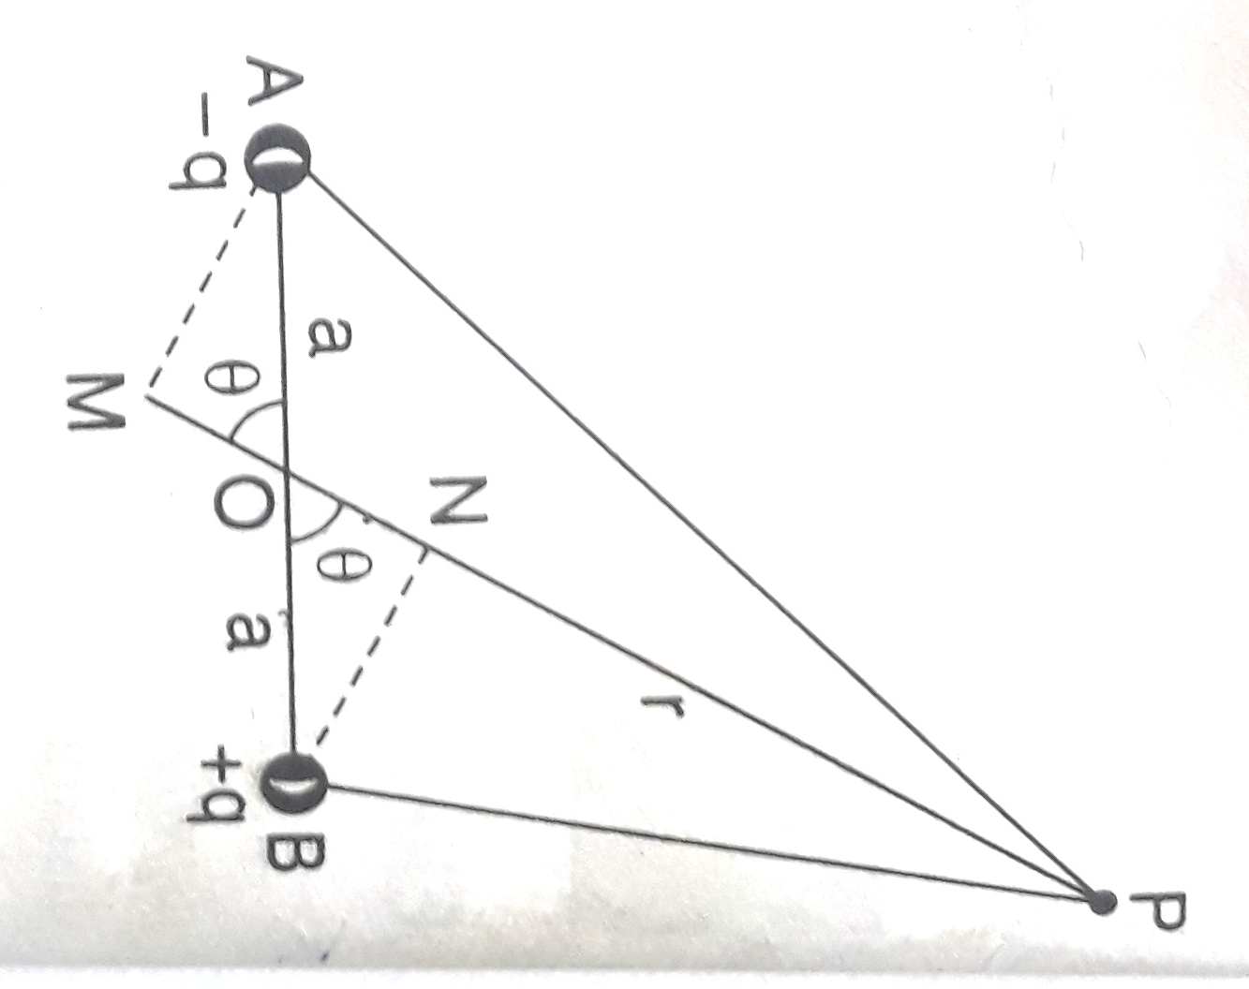
Letter B N and AM be the perpendiculars drawn to OP, now
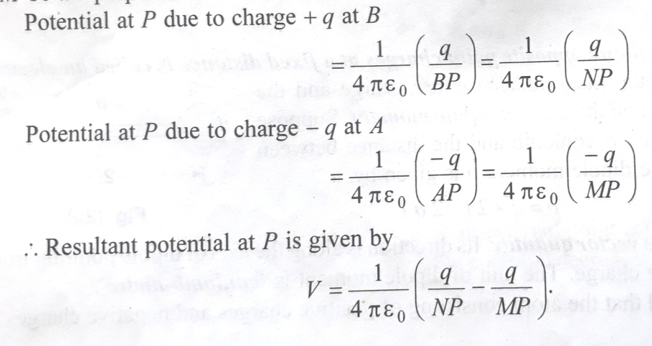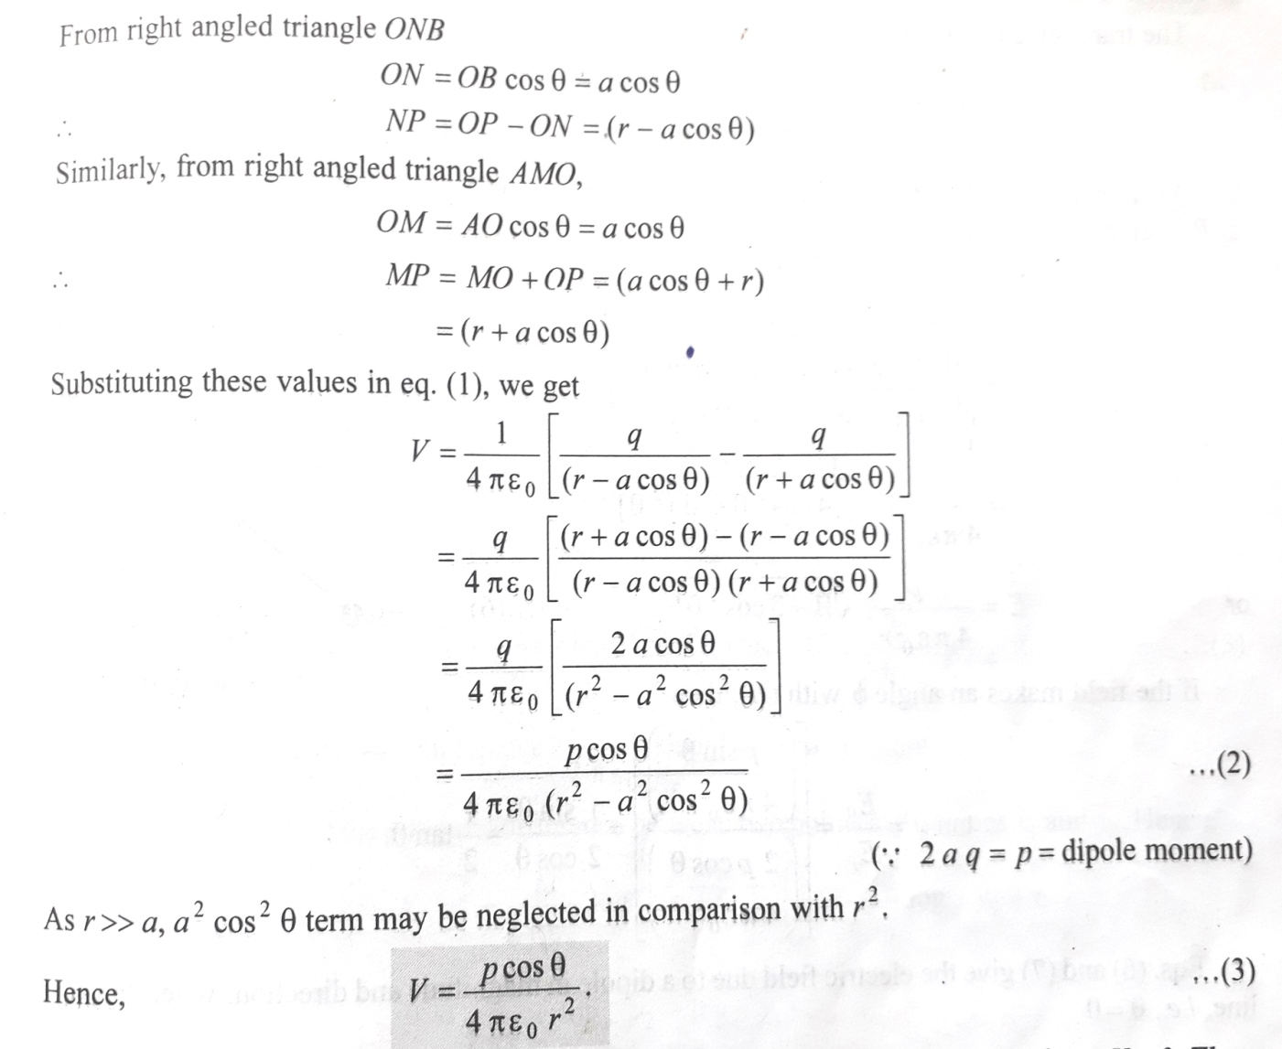
If θ = 90⁰ (on the perpendicular bisector) i.e. equatorial plane, V= 0. Thus the Potential vanishes everywhere on equatorial plane.

Potential due to Uniformly charged circular disc:
Consider a Uniformly charged circular disc with charge ‘q’, let ‘σ’ be the surface charge density. Now we have to calculate the Electric Potential V at any point P on the axis of the disc , at a distance ‘r’ from the centre’O’.
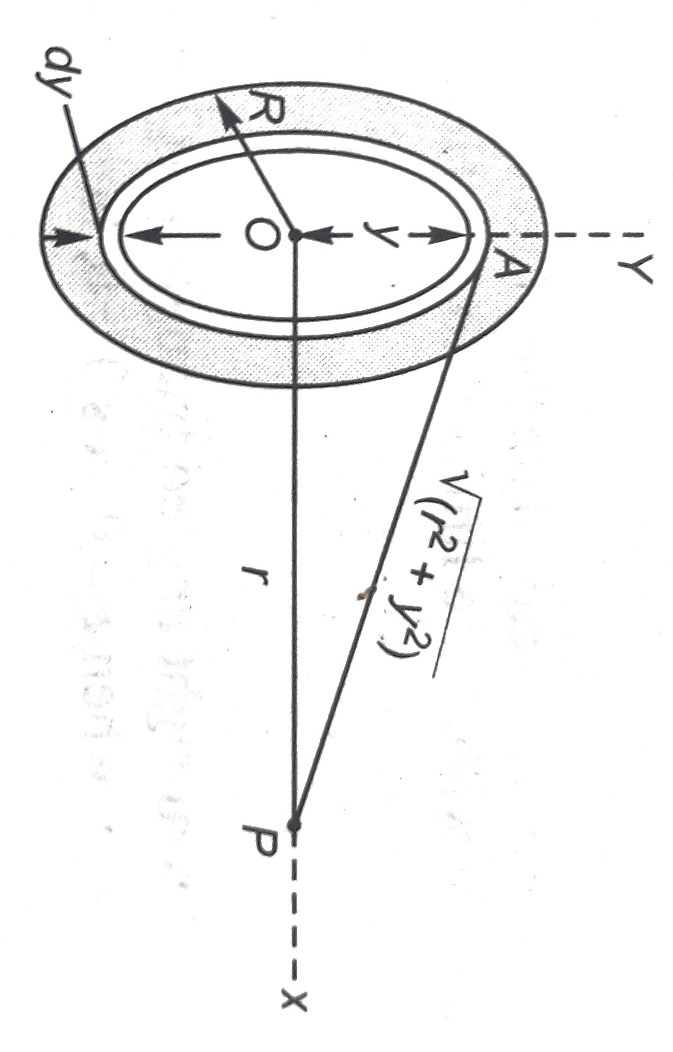
For this we assume the disc as number of circular strips.
Let us consider one such strip, of radius ‘y’ and a width ‘dy’
As the width of the strip is very small, each point on this strip
can be assumed to be at a distance of AP = $\sqrt{r²+x²}$ from
the point P.
The Charge ‘dq’ contained by the strip will be
